

Library Management System
Presented By:
Mazen Hussein Elemam
23016099
Mohamed Omar Sayed
23013434
Mohab Ayman Abdullah
23013662
Abdulrahman Ahmed Mahmoud
23017568
Supervised By:
Dr. Ayman Hasanain
Co-Supervision:
Eng. Ahmed Abdelmonem
Eng. Mohammed Abdelmonem
Eng. Nada Hamdy

EGYPT 2025-2026
1.Introduction

The Library Management System (LMS) is a sophisticated, enterprise-grade software architecture designed to fundamentally transform the operational efficiency of modern library environments. By transitioning from disparate manual ledgers to a unified, centralized database, the system eradicates human error and redundancy, creating a seamless digital ecosystem for its three primary stakeholders: Members, Librarians, and Administrators.
The system provides holistic management of the library's inventory lifecycle, tracking every asset from its initial acquisition and cataloging (entry of ISBN, title, and author data) to its active circulation (real-time availability status, borrowing, and reservation), and finally to its maintenance or archiving. Beyond basic inventory tracking, the LMS serves as an intelligent enforcement engine for library policies. It automates complex logic such as fine calculation for overdue items, eligibility validation (blocking users with outstanding debts), and asset preservation (recording book condition and assessing damage fees). This ensures a secure, transparent, and highly efficient environment where resources are optimized, and administrative overhead is significantly reduced.

2.Problem Definition

The system is designed to resolve specific critical failures inherent in manual library administration:

- Operational Bottlenecks: Manual processing of book loans and returns is slow, creating queues and reducing Librarian productivity.
- Inventory Inaccuracy: Without real-time tracking, books are often listed as "available" when they are lost, misplaced, or damaged.
- Revenue Leakage: Manual fine calculation is error prone. Staff may miss overdue days or fail to assess damage fees consistently.
- Data Vulnerability: Physical ledgers cannot be easily backed up. The digital system introduces backupDatabase() and archiveOldRecords() capabilities to ensure data longevity.
- Lack of Accountability: Manual systems struggle to track who processed a transaction. This system introduces distinct login sessions for Librarians and Admins to enforce accountability.

3. System Description & Architecture

The system is defined by its data structures (Class Diagram) and interaction flows (Sequence/Activity Diagrams).
3.1 Data Actors & Entities
- The System (Core Logic): Acts as an autonomous entity that performs background tasks such as calculateFines(), sendNotifications(), and updateBookAvailability(). It serves as the bridge between the user interface and the database.
- Member: The end-user who interacts with the system to searchBooks(), borrowBook(), returnBook(), and payFine().
- Librarian: The operational staff responsible for the catalog (addNewBook, removeBook), circulation control (acceptBookReturn, calculateFine), and user oversight (blockMember).
- Admin: The system controller with high-level permissions to manageLibrarians() and configureSystemSettings().
- Book: A central entity containing attributes like ISBN, Title, and isAvailable. It tracks its own state, allowing the system to toggle availability instantly.
- Borrow: A transaction record that links a Member to a Book. It stores critical dates (issueDate, dueDate, returnDate) and contains logic to calculateOverdueDays().

3.2 Key Process Flows
- The Borrowing Lifecycle: A multi-step validation process where the Member searches for a book System checks availability Member submits a request System verifies member status (e.g., no unpaid fines) Admin performs a final review Borrow record is created.

- The Return Lifecycle: Includes a physical inspection step. The Librarian checks the book's condition. If damaged, a "Damage Fee" is added to the standard overdue fine (if any) before the book is marked as available again.

4. User Requirements
The system must satisfy the unique needs of its three user groups as depicted in the Use Case diagrams:
For Members
- Self-Service Portal: Members must be able to log in to a personal dashboard to view their borrowing history (viewBorrowedHistory) and active loan status.
- Catalog Interaction: The ability to execute complex searches (by Title, Author, Category) and view detailed book status (Available/Unavailable).
- Reservation Management: Members need the ability to reserveBook() if an item is currently checked out and cancelReservation() if no longer needed.
For Librarians
- Inventory Control: Tools to enter new book data into the database and generate physical barcodes for tracking.
- Member Management: Capability to verify member IDs during physical visits and execute a blockMember() command for rule violations.
- Fine Processing: A dedicated interface to calculate total fines (Overdue + Damage) and mark them as "Paid" in the system.
For Administrators
- Staff Oversight: A secure interface to add, update, or remove Librarian accounts and assign permissions.
- Strategic Reporting: The ability to generateReports() to analyze system usage, financial intake from fines, and inventory status.

5. System Requirements
5.1 Functional Requirements (FRs)
These define the specific behaviors the system is programmed to execute:
- Automated Availability Logic: When a book is borrowed, the system must automatically set its isAvailable attribute to false. Upon return, it must reset to true only after the fine/damage check is cleared.
- Fine Calculation Engine:
  - The system must compare returnDate against dueDate.
  - Logic: If (returnDate > dueDate) THEN Fine = (Days_Overdue * Daily_Rate).
  - Logic: If (Book_Condition == Damaged) THEN Total_Fine = Fine + Damage_Fee.
- Search & Retrieval: The system must return "N/A" or "Not Found" messages if a search query yields no results, preventing users from requesting non-existent books.
- Notifications: The system must trigger alerts for specific events: "Book Approved," "Request Rejected" (with reason), and "Fine Details."
- Database Maintenance: The system must provide functions to archiveOldRecords() to keep the active database performant and backupDatabase() to prevent data loss.
5.2 Non-Functional Requirements (NFRs)
These define the quality attributes of the system:
- Security & Access Control:
  - Authentication: All users (Librarian, Admin) must authenticate via a login mechanism.
  - Authorization: The system must enforce Role-Based Access Control (RBAC). For example, a Member cannot access the addNewBook function; only a Librarian can.
- Data Integrity: The system must ensure that a Book cannot be deleted if it is currently linked to an active Loan record.
- Performance: The "Search" function must be optimized to handle queries against a large database of books without significant latency.
- Scalability: The architecture (separating the Database from the System logic) supports adding more books and members without rewriting the core application code.
- Usability: The system must provide clear feedback messages (e.g., "Member Not Eligible," "Book Successfully Issued") to ensure users understand the outcome of their actions.

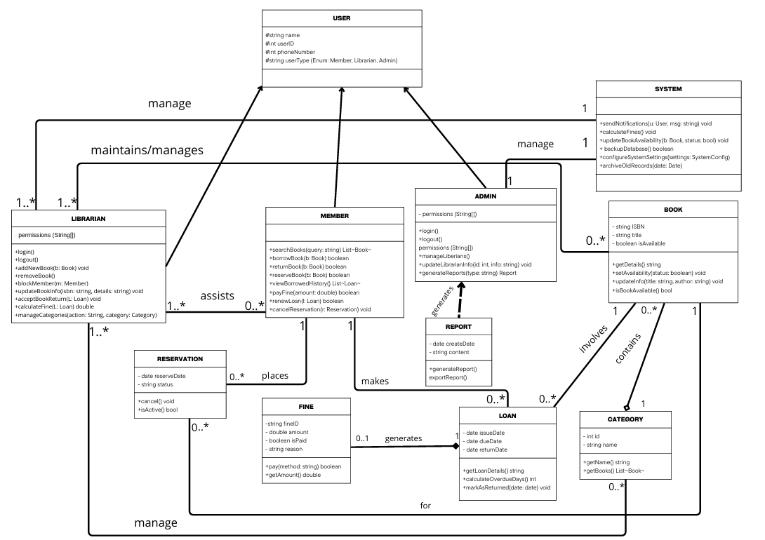
CLASS DIAGRAM

ACTIVITY DIAGRAM
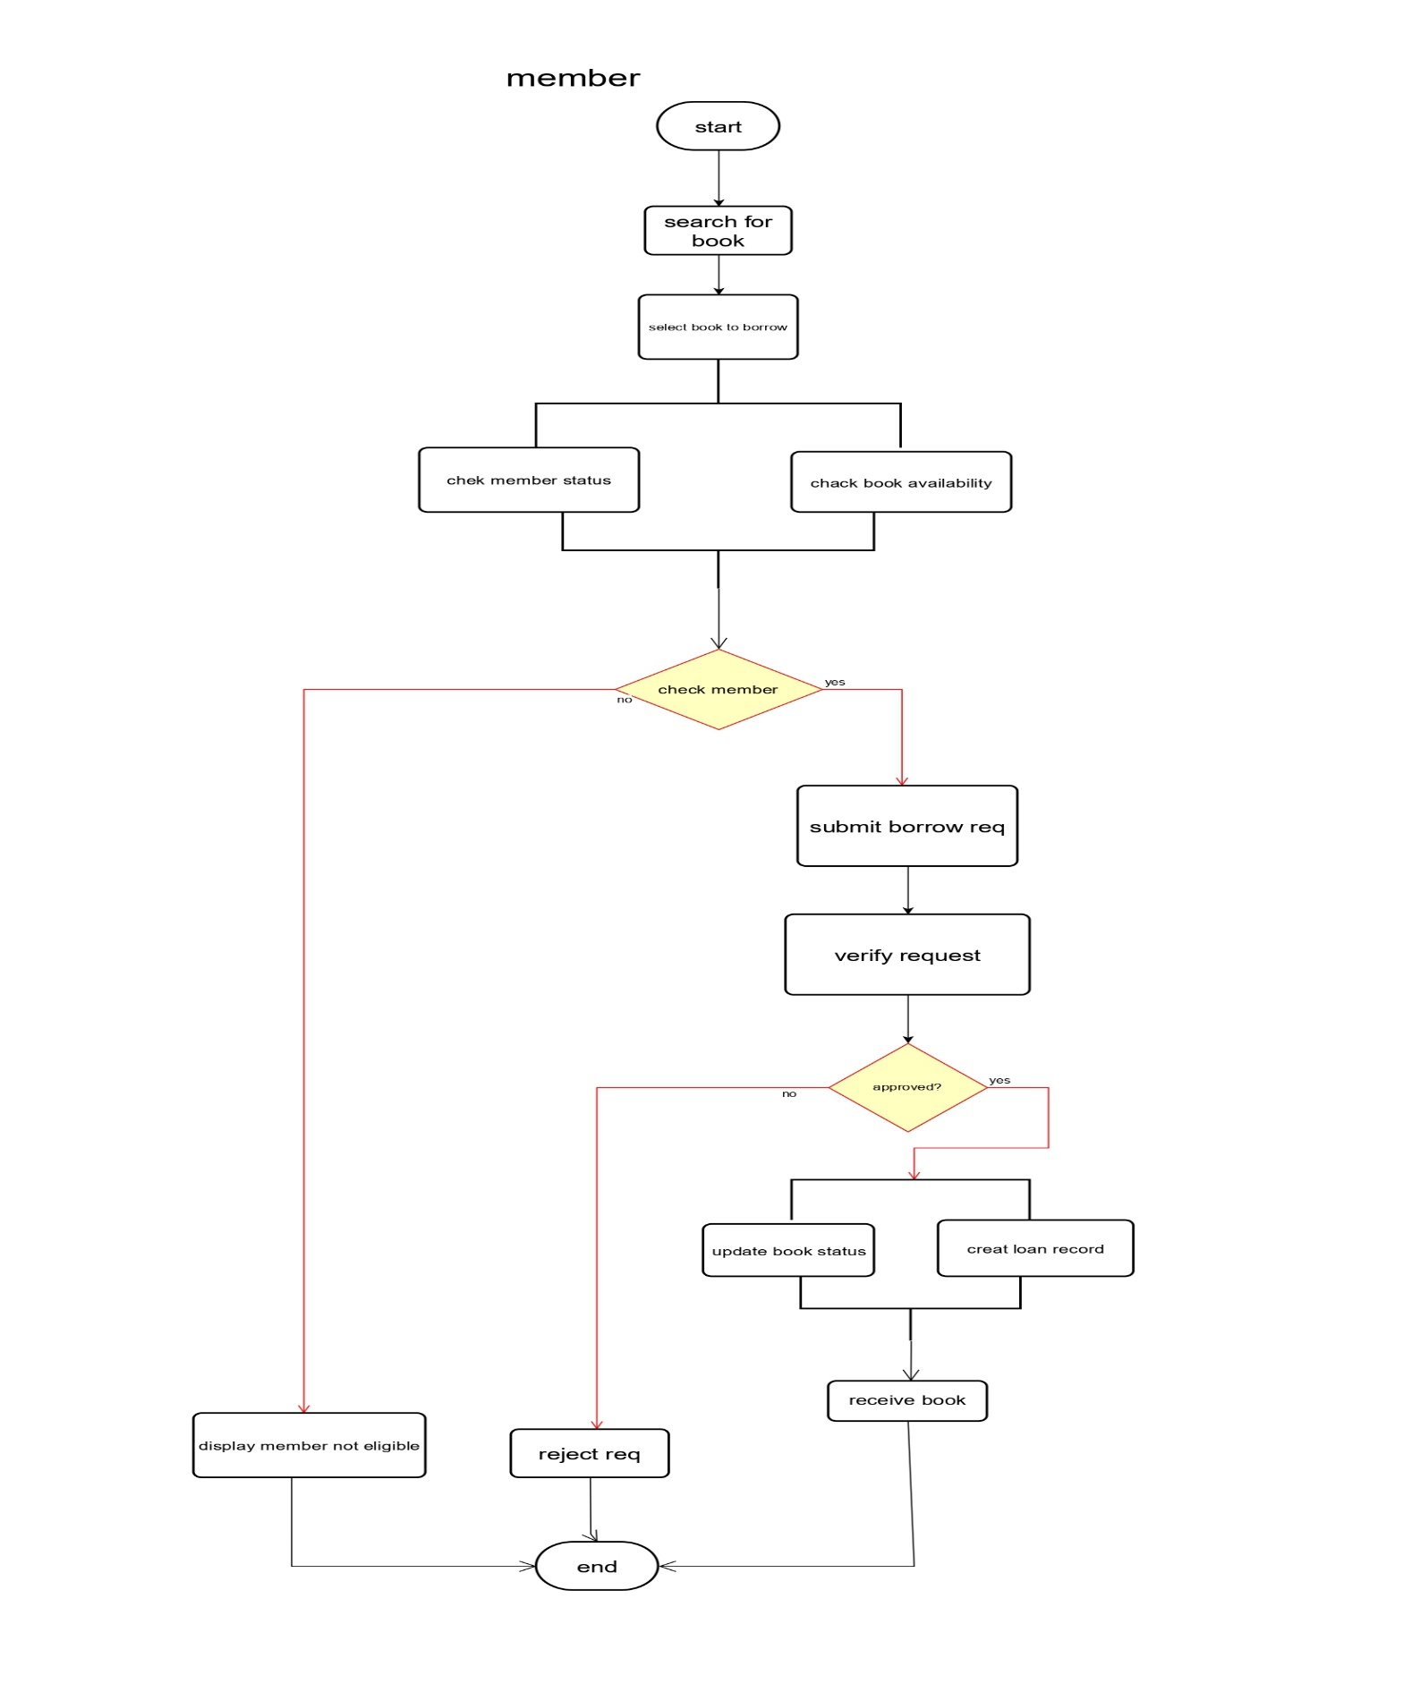
1.Borrow Function

ACTIVITY DIAGRAM

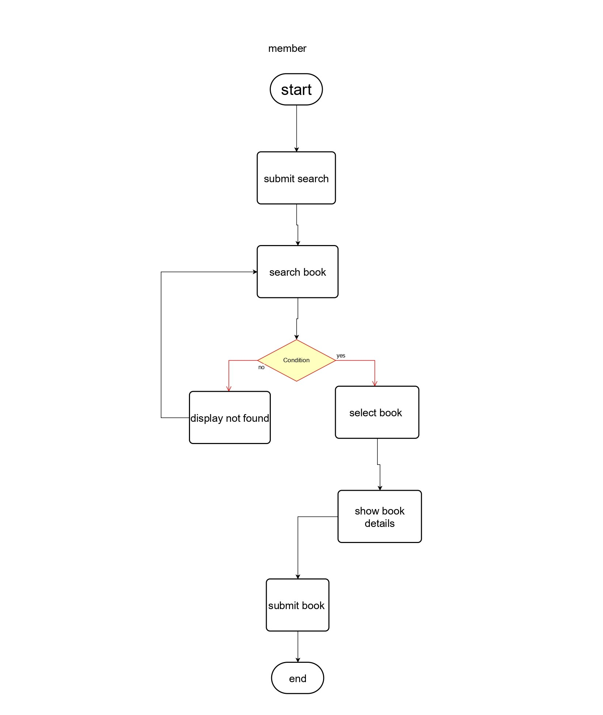
2.Search Function

ACTIVITY DIAGRAM
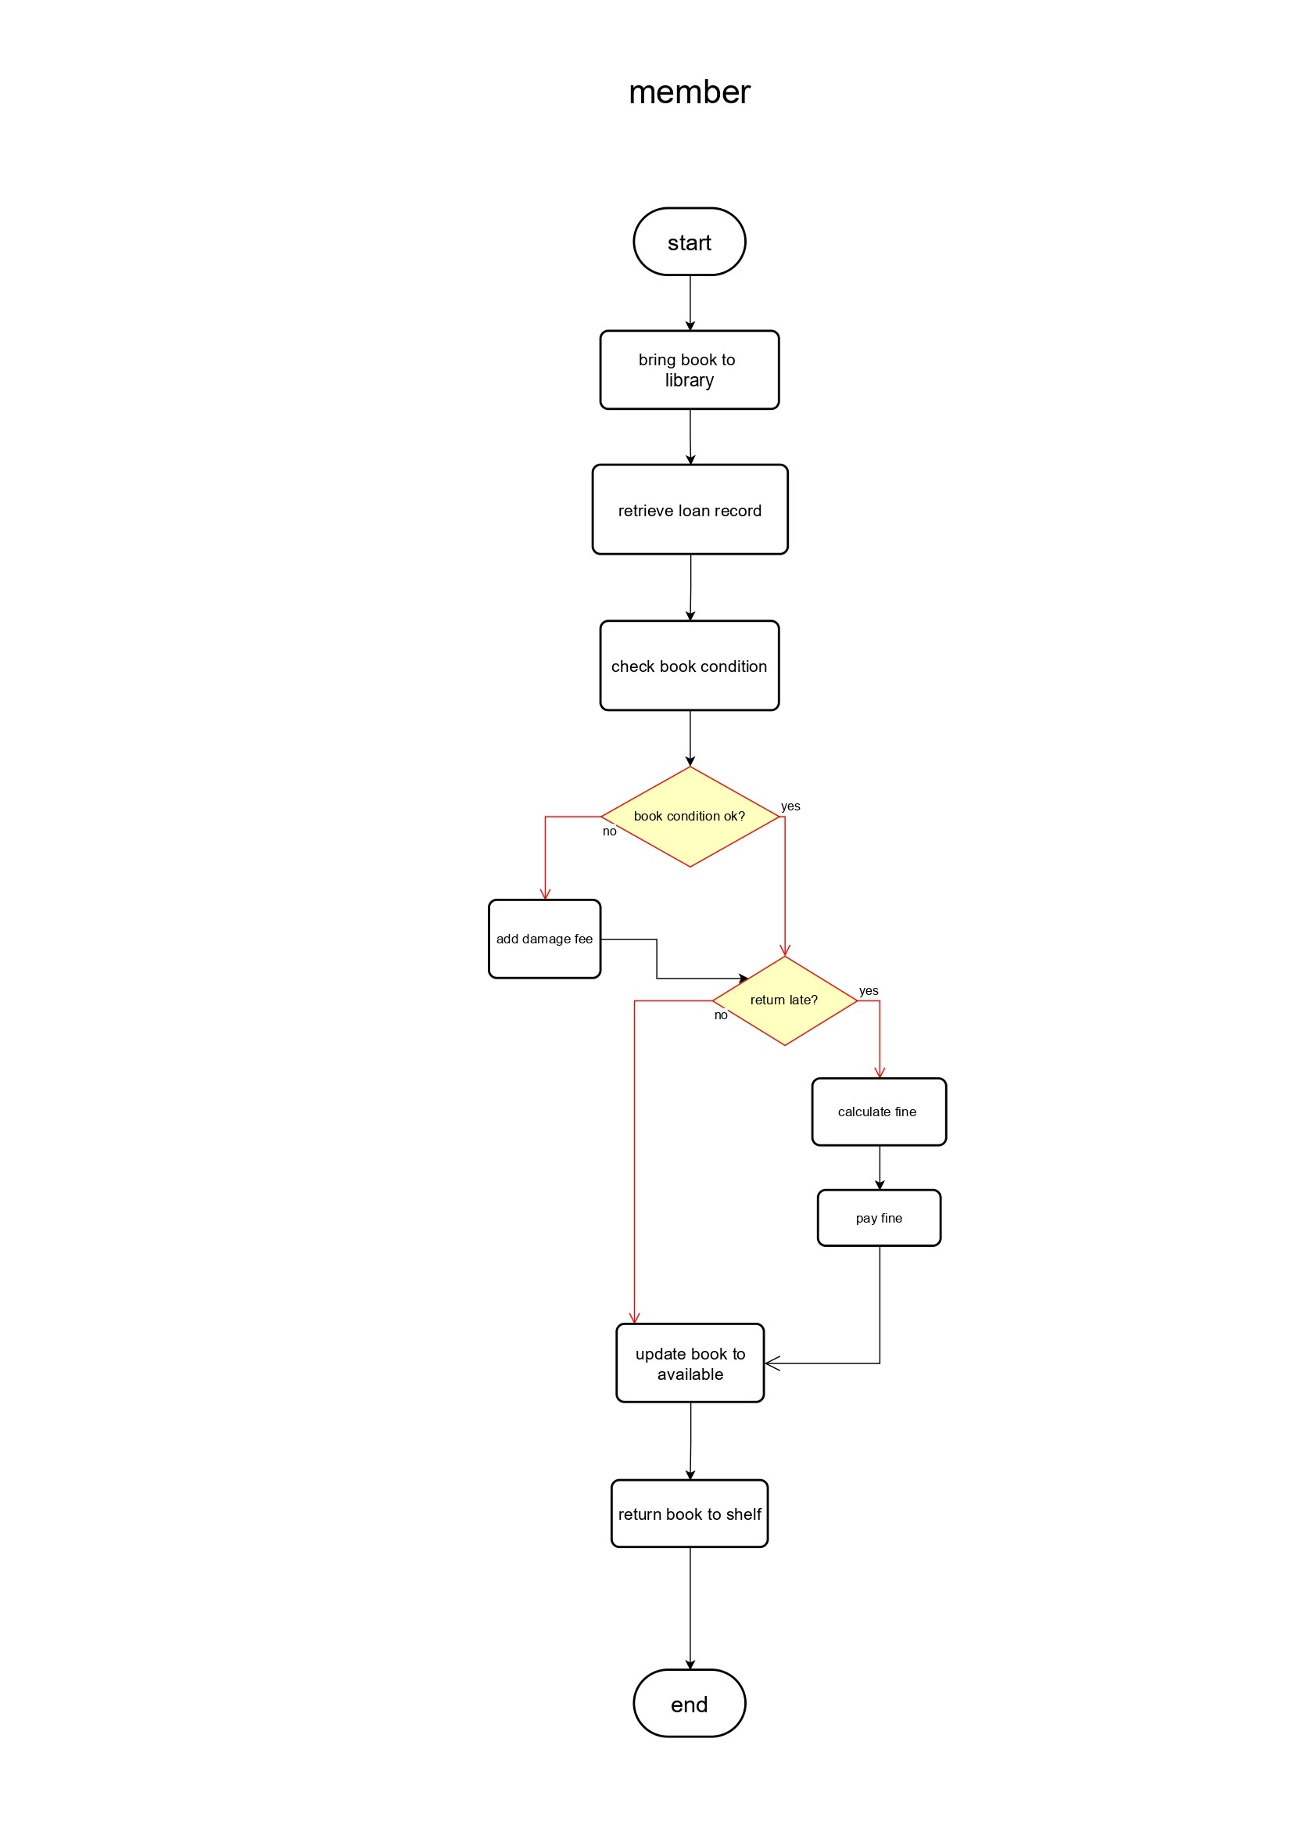
3. Return Function

DATA FLOW DIAGRAM
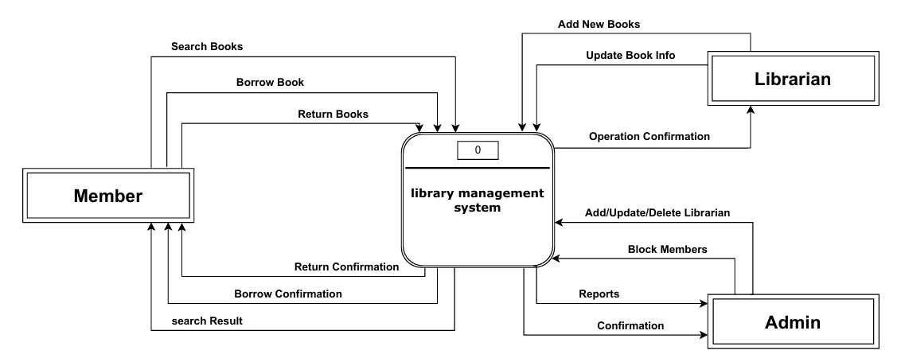
Level 0

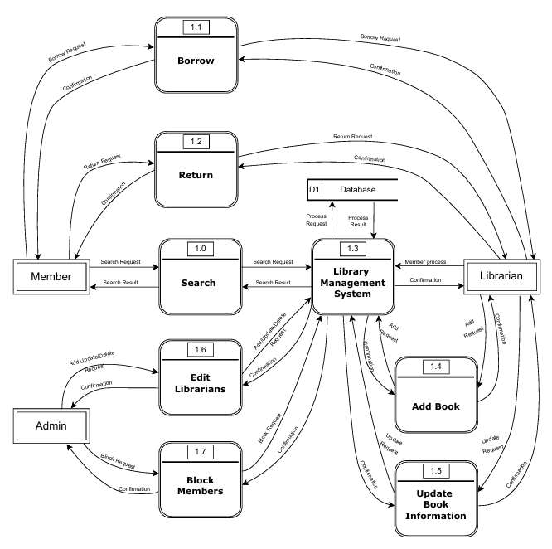
Level 1

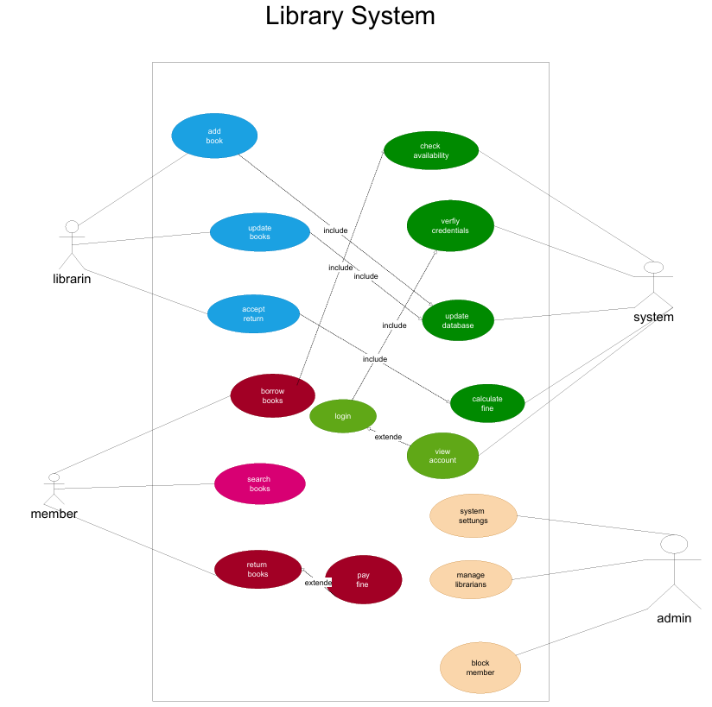
USE CASE DIAGRAM

SEQUENCE DIAGRAM
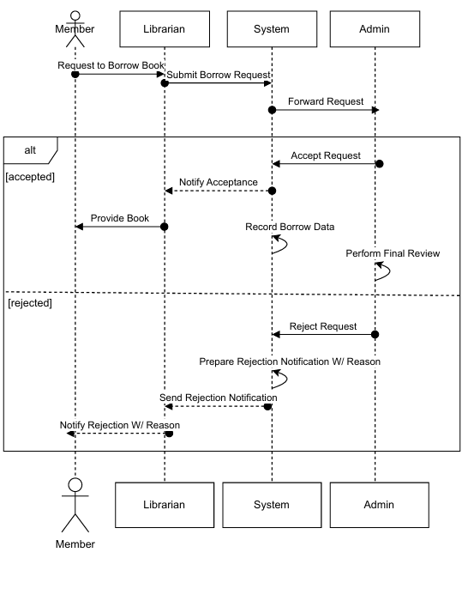
1.Borrow Function

SEQUENCE DIAGRAM
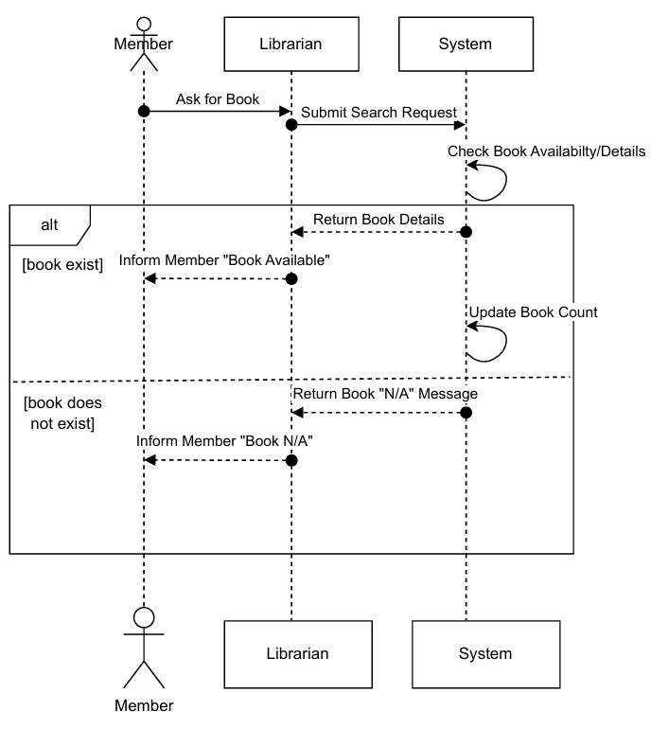
2.Search Function

SEQUENCE DIAGRAM
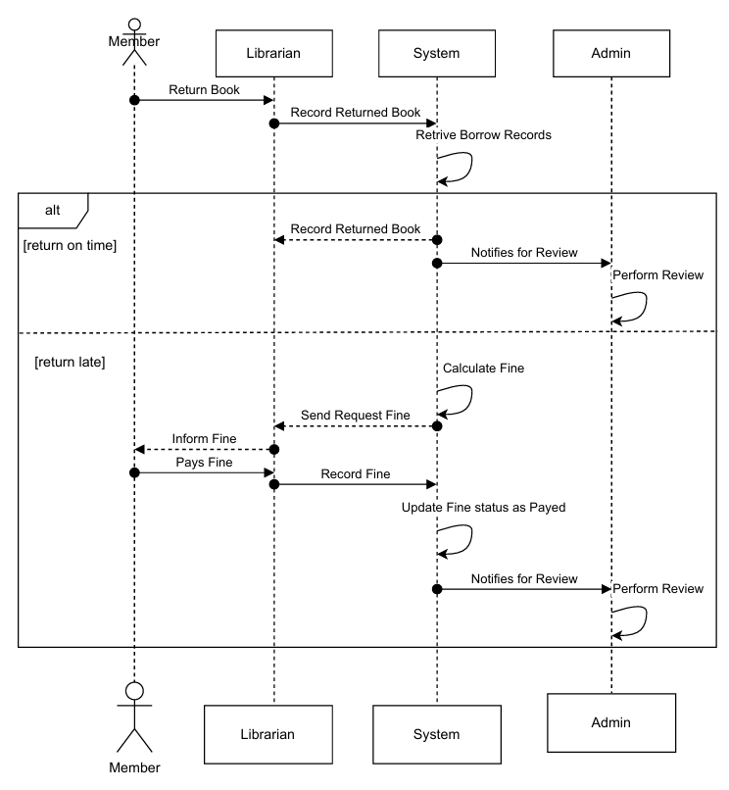
3.Return Function

SEQUENCE DIAGRAM
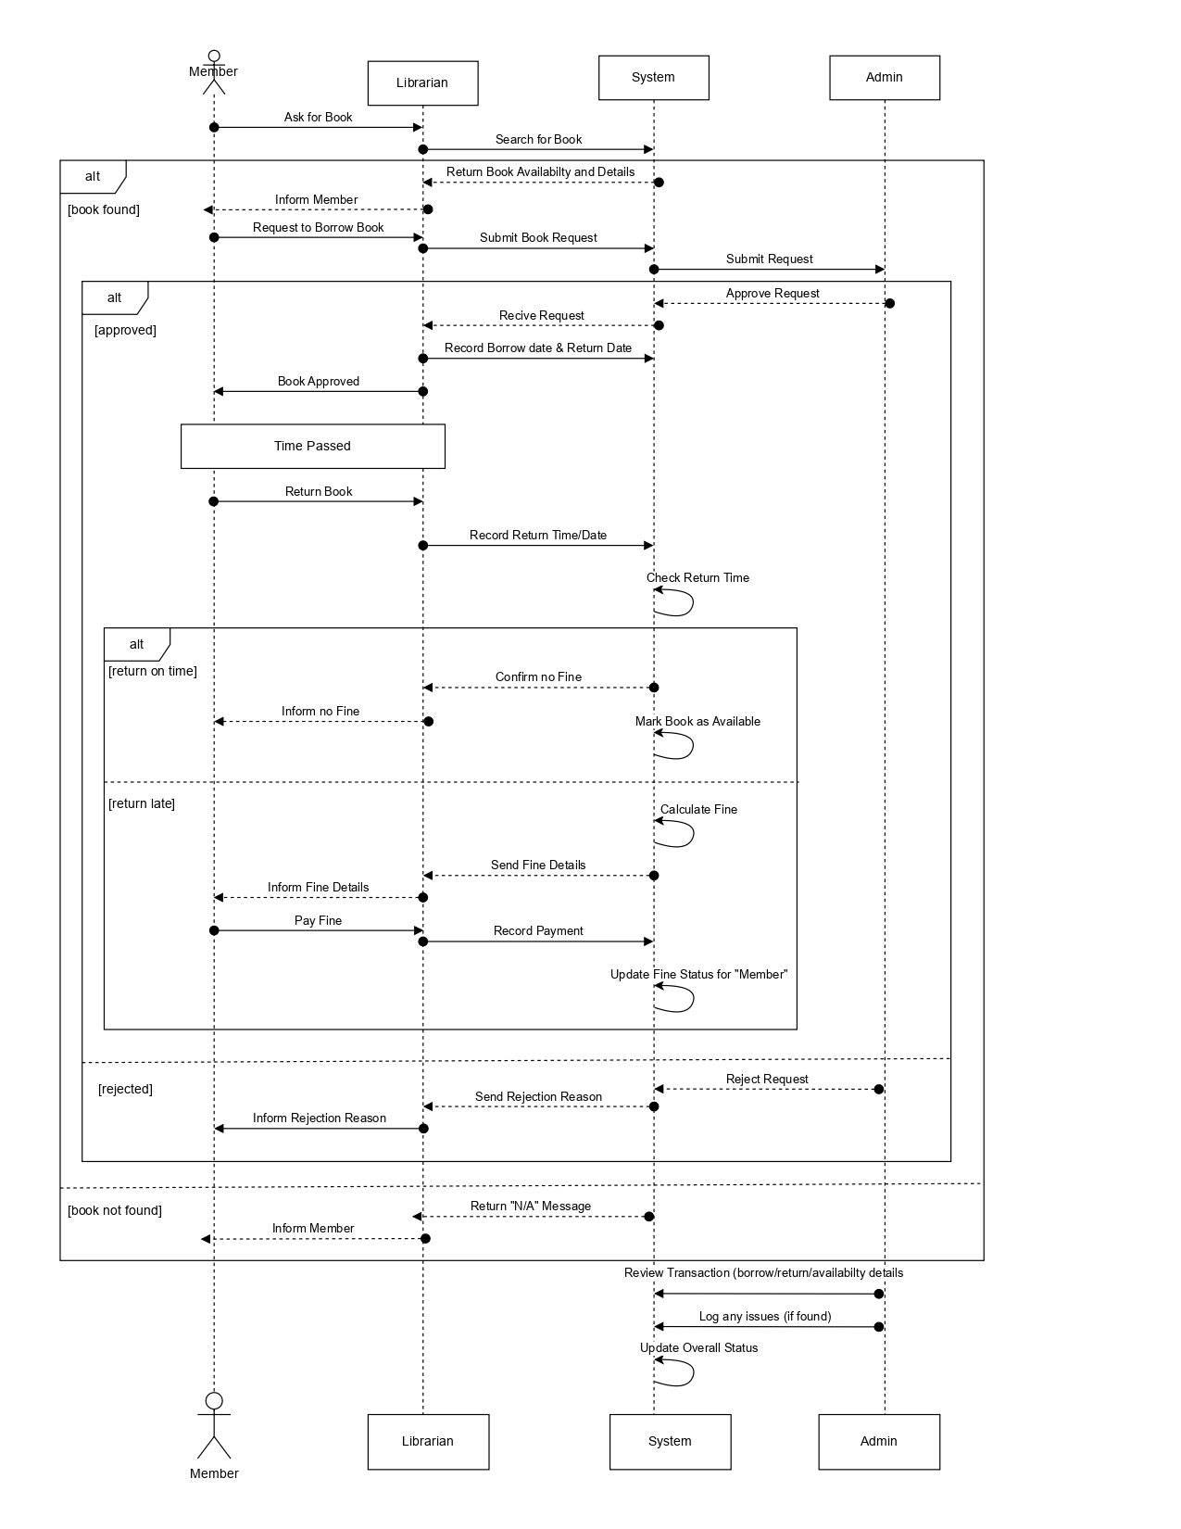
Final Diagram

